Fair Trade on Peruvian textiles enterprises as a path for social development for women and ancestral techniques preservation.
By Sandra Huayanay Román.
Bachelor on International Business.
Inca Garcilaso de la Vega University.
Lima, Perú.

According to the Peruvian Ministry of Production, the Peruvian textile industry represents 1,3% of the Gross Domestic Product, and 8,9% of the national manufacturing production. The textile industry’s exports generated 1,196 million dollars in revenue in 2016 alone. Moreover, this industry generates more than 400,000 jobs making it the second most important industry in Peru behind the metallic industry. The importance of Peruvian textile in our own history has developed as ancient techniques, from pre-Inca and Inca periods, have been passed through generations, mostly by women with little or no education who learned from their parents and later, who pass this knowledge to their children. This article looks to demonstrate that Fair Trade related enterprises not only preserve the traditions, but also implement programs that can support future workers in learning new and modern techniques as well as giving them the opportunity to be recognized for their work. They also aim to make workers part of a team and through enhancing their work-skills to help change their lives.
Peru and Fair Trade: a brief history.
In Peru, the first Fair Trade footprints began to be seen in the seventies when catholic-church representatives and artisans united their forces to build the first organizations, or social movements, of Fair Trade in the country. During that time, Peru suffered one of its worst moments in history and it’s accurately described by Alfonso Quiróz who stated the military dictatorship as having left a “harmful legacy”. The increase of cocaine production not only produced a dangerous threat to national security but also corrupted every single possible government institution to set unlawful businesses and increase the power of drug cartels. Peru was in a downhill spiral that seemed to be a trip with no return. Fair Trade became an essential movement when Shining Path and MRTA, two of the most horrendous terrorists’ organizations started to set their violence and spread their atrocities in the most isolated towns and regions of Peru during the eighties. Many people from all the regions of the country started to move out and leave their places of origin in a more pronounced way, than in the seventies, to live in Lima and make a new beginning away from the violence. Artisans, handcrafters and farmers saw the capital as a place where they could succeed. Antonio Romero Reyes is perhaps one of the most respected academic authors who described the Peruvian Fair-Trade evolution. Romero Reyes states that in the eighties, International organizations demanded agriculture products and handicrafts with some quality or environmental standards, and in return they would offer a good price to producers. However, no international standards organizations were involved. Furthermore, Fair Trade as a movement adopted the name of "Community Trade", which aimed to build a link between producers and local markets. I can also affirm the previous statement as I personally grew up watching these local fairs all around the country while accompanying my parents on their trips. Fairs such as "From the farm to the pan" or "community fairs" are famous nowadays. It's necessary to clarify that these fairs were only agriculture- related, which means the products offered were only vegetables and fruits. As these community fairs started gaining popularity, the market for bio-products emerged, and the need to have some certified products also increased as well as the need for support from the local authorities. Romero Reyes also found out that the first bio-fairs, supported by the local government, were in Miraflores in 1999 as a part of integrating the local producers and consumers with high incomes. Later, bio-fairs were spread in many other high-income cities with Lima applying the same business model and benefitting from local authorities support. However, the fact that only consumers with high-income were only targeted by these enterprises meant the affects of its expansion were not felt in the local market. On the other hand, Brisa Ceccon expresses the necessity of the fair trade related organizations in Latin America to get together to find spaces for “collaboration and dialogue regarding the need to plan and coordinate activities associated with Fair Trade and other alternatives trades”. In the 2000s Peru seemed to see the light again, after a long period of corruption and violence lasting for more than 20 years. In 2014, Fairtrade International listed Peru as the top-ranking country for generation of revenues from producer sales reported from Fair Trade sales (185.8 million of euros). Plus, it is stated in that same year that Fair Trade in Peru some 70,000 families were involved or working as part of the movement and 174 organizations related to fair trade are associated to it. However; only 13 organizations are certified by the World Fair Trade Organization, 11 of which work alongside artisans, handcrafters and knitters.
Fair trade and the Peruvian government involvement.
As stated by Alfonso Cotera “there are few local authorities and government officials that know anything about Fair Trade in the region. There are no programs or political promotion to support Fair Trade in different public bureaus in any of the countries from the Andean Community (CAN)”. Additionally, Cotera and Romero Reyes criticize the scarce government effort to work on Fair Trade, or any movement associated to it, such as the inexistence of a government department that works specifically on Fair Trade promotion and development, and no database about enterprises that work on fair trade or are associated to it. I can say even it’s quite shameful that this absence of laws and policies related to fair trade is truly coming from the country ranked first for generation of incomes from Fair Trade producers’ sales in the world. However, there was one mayor project the Peruvian government and international cooperation worked on together which gave some important and relevant results. This project was adapted to the Peruvian business environment, as well as the principles of Fair Trade, and was focused on the textile industry. Enterprises that applied to this program could have a Fair Trade-related certificate issued by the Peruvian Ministry of Foreign Trade and Tourism. In 2009, 200 enterprises related to the textile industry applied to the program. From this period to 2015, 122 enterprises were trained within the program. Only 13 were certified and granted a position within national and international fairs promoted by the Ministry of Foreign Trade and Tourism. In 2016 their presence in fairs declined to only 6 enterprises that could display their products in Peru Moda Fair, the biggest fashion fair promoted by the Peruvian government. Also, it’s not known whether the program will continue in the future.

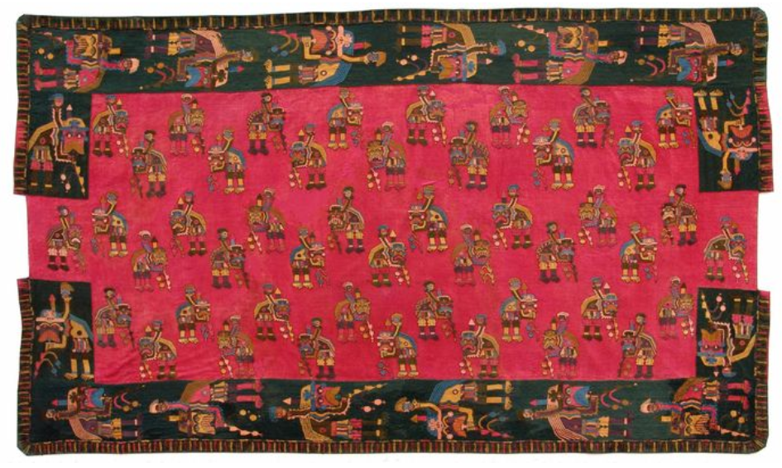
Paracas Textile (Photo from La República Newspaper)
Women
The last project by the peruvian government, with international cooperation, found 70% of the workers within the textiles enterprises that applied for the Fair Trade certificate were women. According to the study made by the National Institute of Statistics and Informatics in 2014, Peru was a country that showed levels of inequality when it comes to education. For instance, 47,3% of women aged between 10 and 14 years old had not finished their primary school education. Plus, 46 % of women aged between 15 and 19 years old, who originated from the rainforest regions, had notfinished their high school education.
On the other hand, 39,7% of women that live in Huanuco, a region located on the andean side of the country have not finished their primary school education. As stated, this implies that 40,9% of women who have not finished their primary school education come from rural areas. It’s also necessary to indicate that peruvian women are vulnerable to suffer many types of violence. As claimed by Peruvian Ministry of Women and Vulnerable Communities 121 women were murdered and 247 women were subject to attempted murder in 2017. The Public Prosecutor Offce received only 93 of murder and 46 of murder attempt cases against women in 2017. On the positive side, the Ministry of Women and Vulnerable Communities created the Women Emergency Center, an office that has the purpose of orienting women who were subjected to violence, and their respective families on legal procedures to find justice. This office inaugurated in 2017 received 95,317 cases of many types of violence against women in the country.

The importance of Fair Trade as a path for social development
In Peru where Fair Trade is little and limited it could be a path to social development. Even though government efforts seem to be scarce, it’s not possible to rely on one or more public institutions. People, through civil associations, can work and make an impact. Even though Peru has very great number of people working within the textile industry, and a heritage of textile production, very few enterprises have their eyes set on the opportunity of fair trade within textiles. This could generate more jobs, especially for women, who mostly know the beautiful art of knitting, and help them build economic independence. This is crucial for women who have run away from the violence of their towns, who have no education and are still running from physical or sexual violence, and who can protect themselves with only one weapon: knitting, taught by their parents. Once, I was in the streets wandering when I saw a woman wearing her cultural garments. She had on display beautifully knitted ponchos, scarves and gloves. I asked her how she learned to knit. She told me her mother taught her, no need to go to any fashion school to do it. She saw how her mother, and friends, gathered together to produce garments made of alpaca, wool or cotton. She wanted to learn too. Now it was her only way to survive in the big city after escaping from a place where she could see no future. This casual conversation became an inspiration for me to research more about it. I asked myself if I was the only one thinking knitting could be a pathway for women to give economic support to their families. Gladly, I found I was not the only one. In Peru, there are many Fair Trade related enterprises whose programs focus on supporting future workers in learning new and modern techniques as well as giving them the opportunity to be recognized for their work and for their knowledge of ancestral textile techniques. They also aim to make workers part of a team and through enhancing their work-skills help change their lives. This is something that is not widely known or broadcast to a wider audience. It’s time to show them now.
REFERENCES
- Instituto Interamericano de Cooperación para la Agricultura (2008). El Comercio Justo como Alternativa para el Desarrollo Equitativo: Propuesta para una Estrategia de Fortalecimiento y Consolidación del Comercio Justo en Colombia. San José, Costa Rica. Pag. 113-115.
- Corporación Andina de Fomento- CAF (2016) Nuevos Caminos para el Desarrollo. Lima, Perú. Pag. 31-47.
- Toledo Espinoza, Elías (1989). Historia del Perú. Lima, Peru.166-167.
- Fridell, Gavin (2004) The Fair Trade Network in Historical Perspective. Canadian Journal of Development Studies Volume XXV, No. 3, 412-428. The Canadian Fair Trade Network. Available online.
- Reynolds, Laura T; Murray, Douglas L; Wilkinson, John (2007) Fair Trade: The Challenges of Transforming Globalization. Abington, United Kingdom. Pag. 57-60.
- Fichtl, Eric (2007) The Fair Trade Movement in Historical Perspective: Explaining the In and Against the Market Predicament. Master Thesis. Available online.
- Stiglitz, Joseph; Charlton, Andrew (2006). Fair Trade for All: How Trade Can Promote Development. Oxford University Press. Pag. 22-23,29,36-37.
- Portocarrero, Felipe; Tarazona, Bruno; Camacho, Luis (2006). Situación de la Responsabilidad Social Empresarial en la Micro, Pequeña y Mediana Empresa en el Perú. Centro de Investigación de la Universidad del Pacífico. Lima, Perú.
- English Translation to “Instituto Nacional de Estadística e Informática-INEI”.
- English Translation to “Ministerio de la Mujer y Poblaciones Vulnerables”.
- Ministerio de la Mujer y Poblaciones Vulnerables- Estadísticas sobre Feminicidio (accessed July 2018). https://www.mimp.gob.pe/contigo/contenidos/pncontigo-articulos.php?codigo=39

Ministerio de la Producción- Estudio de Investigación del Sector Textil y Confecciones (accessed July 2018). http://demi.produce.gob.pe/images/publicaciones/publie178337159547c39d_11.pdf
Oxfam Magasins du Monde (accessed February 2017). https://www.oxfammagasinsdumonde.be/blog/article_dossier/ciap-une-organisation-dont-les-actionnaires-sont-les-artisans/
English Translation to “De la Chacra a la olla” and “ferias comunales”.
Fairtrade International (accessed February 2017). https://annualreport15-16.fairtrade.net/en/growing-better-futures/
Diario Gestión (accessed July 2018). https://gestion.pe/economia/comercio-justo-alberga-70-000-familias-pequenos-productores-peru-61155
World Fair Trade Organization (accessed July2018). https://wfto.com/find-supplier
The name of the project was “Programa Piloto para el Sistema de Comercio Justo en el Clúster Textil y Confecciones Peruano. As it is said, it was a pilot program focused on textile enterprises that wanted to be recognized on Fair Trade practices, therefore; it meant those enterprises were eligible to have a certificate as well as the use of a Fair-Trade label created by PROMPERU, a government entity in charge of promoting trade and tourism in Peru.
English Translation to “Instituto Nacional de Estadística e Informática-INEI”.
English Translation to “Ministerio de la Mujer y Poblaciones Vulnerables”.
Ministerio de la Mujer y Poblaciones Vulnerables- Estadísticas sobre Feminicidio (accessed July 2018). https://www.mimp.gob.pe/contigo/contenidos/pncontigo-articulos.php?codigo=39
Ministerio de la Mujer y Poblaciones Vulnerables- Estadísticas- Atención Integral a Víctimas de Violencia Familiar y Sexual (accessed July 2018) https://www.mimp.gob.pe/contigo/contenidos/pncontigo-articulos.php?codigo=36

